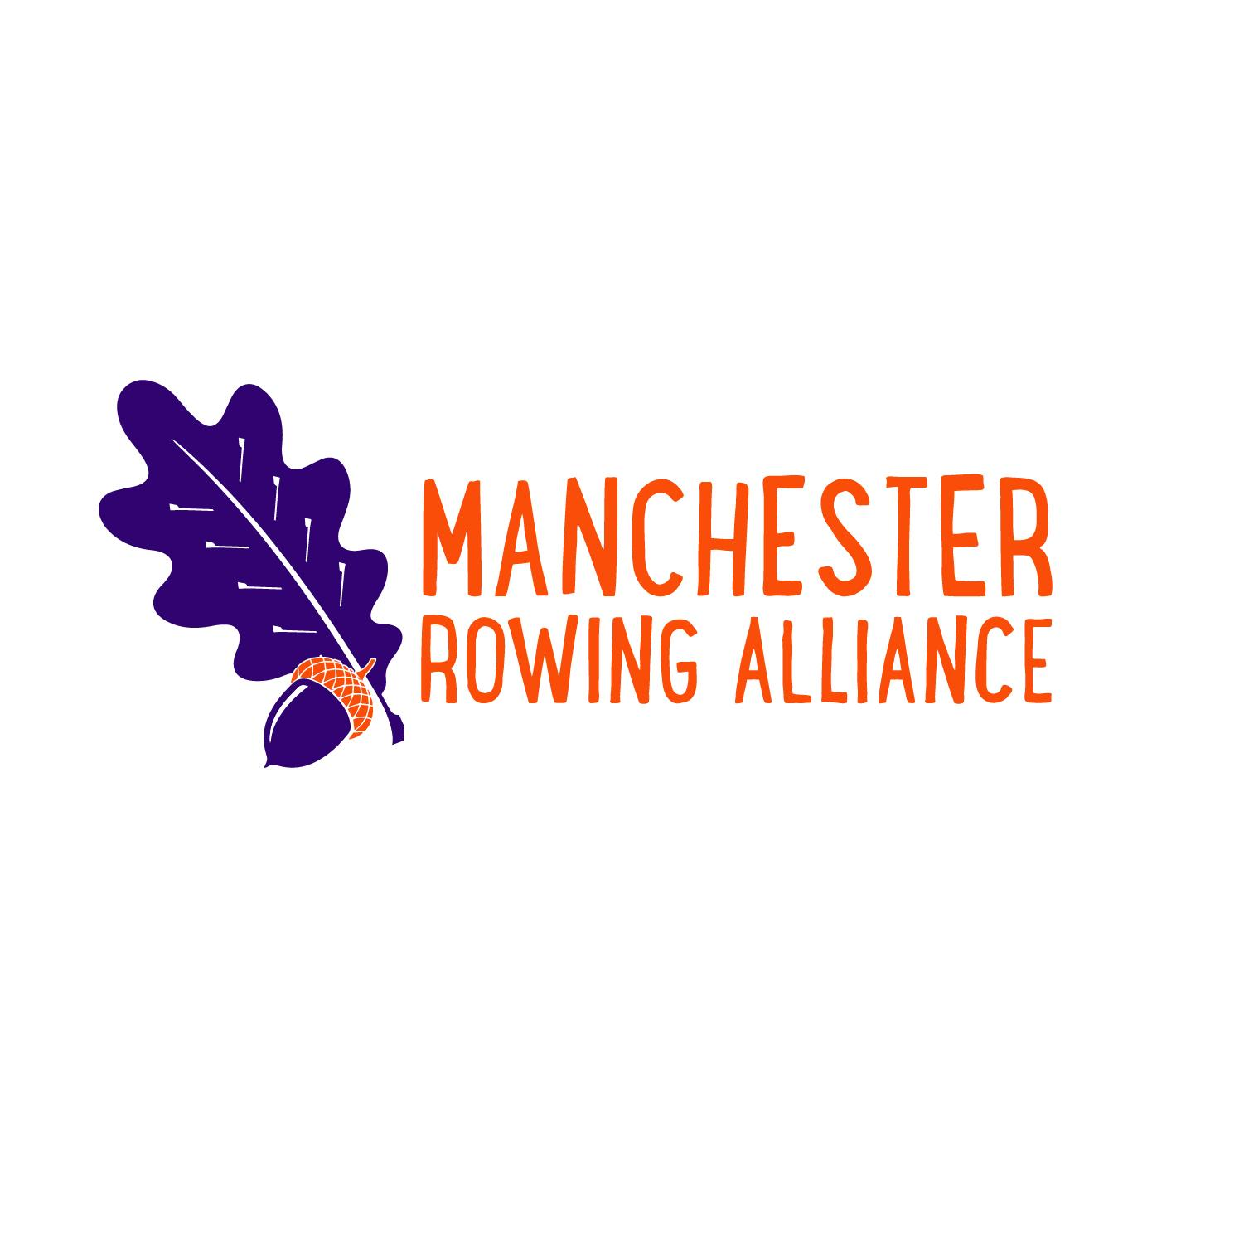
Manchester Rowing Alliance Handbook

I. Attendance and Expectations
II. Registration
III. Rowing Gear
IV. Regattas
V. How to be a Supportive Parent of an Athlete
VI. Volunteering and Fundraising
VII. Code of Conduct
VIII. Links
I. Attendance and Expectations
Rowers are expected to attend all practices. If you are in school, you are expected to attend practice. It is your responsibility to contact Coach Clough before 12 noon to report any absence. Regatta absences will be reported BEFORE the season starts.
- Excused absences from school qualify as excused absences from practice and regattas ONLY if you have notified the coaches ahead of time. Examples of excused absences include: illness from school, religious holidays, school required attendance activities (band, art show, field trips), and bereavement.
- The regatta schedule is given out prior to the season. All are expected to attend all regattas, regardless of whether boated or not. If, for some reason you are not able to attend a regatta (excused or unexcused), it is your responsibility to notify Coach Brenda or Coach Clough BEFORE the season starts.
- If a rower has an unexcused absence at practice in the week prior to a regatta, that rower will not race in said regatta. The rower, however, is expected to attend the regatta as they are part of a team.
- An unexcused absence from a regatta will likely result in not racing in the next regatta. Failure to attend a regatta affects the rest of the team and the possibility of scratching a boat. A conference will be held with the coaches to determine what role you will have on the team for the rest of the season. There will be NO REFUNDS of tuition.
- Come to practice to practice. When a rower arrives is it expected that he/she will begin preparation for practice; this could include warm ups, collecting oars, getting launches in the water, and any other activity to be prepared to row. You will be appropriately equipped, attired and ready to contribute to your team. No drama allowed. We are not a social club, we are a rowing club.

II. Registration
To register with MRA:
- Go to http://www.rowmanchester.org.
- If you are a returning rower, fill out application. At this time there is no application for a new rower.
- Login or create an account, complete the registration and payment for the season.
- Download a swim test form and complete (this needs to be done only one time for Novices, not every season.)
- Order your personal MRA uniform from the JL Racing link: https://store.jlracing.com/store.jsp?ID=1M2474B05JL81K4LBIKIHDF1MCB29F67H2LE0HMBKIEAAJ
- Sign consent form electronically.
- Choose to pay a $75 fee per season or contribute to hospitality tent via SignUp Genius for each regatta.
- A US Rowing Membership is required prior to the start of the season. The Basic Membership at $9.75 is adequate for most regattas. All rowers competing in US Rowing sanctioned regattas must be Championship Members. Make certain that you associate with the team Manchester Rowing Alliance when you are becoming a member. http://www.usrowing.org/membership/
- US Rowing waivers are based on the calendar year and may need to be signed again online for all rowers prior to the start of the season http://www.usrowing.org/sign-a-waiver/.
- Download and connect to iCrew, an application that will be used for attendance, lineups, and equipment tracking. https://www.icrew.club/signup.php?crewOrg=MRA&crewOrgID=94b4aba9-be7c-8f1e-9ee2-a750571218aa
- A physical MUST be filled out and signed by a doctor and turned in by the first day of practice. A physical within the past 12 months will be accepted.
It is mandatory that all forms, registrations, and payments be completed by the first day of practice. If all the above is not completed, signed, and submitted, rowers will not be allowed to participate. This will be enforced and no exceptions will be made.
III. Rowing Gear
Required:
- Personal uniform purchase through JL racing at time of registration. Rowers can choose to wear a unisuit OR the MRA racing top and MRA shorts. All are available at: https://store.jlracing.com/store.jsp?ID=1M2474B05JL81K4LBIKIHDF1MCB29F67H2LE0HMBKIEAAJ
- Wrenches are required. You will need a 10 mm and a 7/16 inch, which can be purchased at any hardware store. Consider spending a few extra dollars on ratcheted wrenches.
- Reusable water bottles. Do not bring disposable bottled water to practice.
- High visibility shirts in the colors of lime-green, orange, or pink. This is a safety mandate to keep our boats visible on the water to other boaters. They MUST be high viz- not a peach, salmon, or light blue or pink. The coaches have the last say as to whether is it hi-viz or not.
- Each practice will have warm up time that may include running, so appropriate footwear is required.
- Socks must be worn in the boat.
- When in the boat, all clothing must be form-fitting. Loose clothing can get caught in the seat tracks, potentially causing injury to the rower or damage to the boat. Spandex, compression shorts, biking shorts, or tights are all appropriate gear. Basketball shorts, sweatpants, and kangaroo pocket tops are all examples of loose clothing that SHOULD NOT BE WORN. They may be worn while on land for layering, but not in the boat.
Not required but highly recommended for practices and regattas:
- Small towels for wet launching.
- Athletic tape, Band-Aids, moleskin, or super glue for blisters.
- An extra set of clothing, including socks.
- Team clothing with MRA logo (great for regattas).
- Coxswains may require additional layering due to the stationary position they have in the boat. Watches and waterproof clothing are recommended.
IV. Regattas
- You are given the regatta schedule ahead of time. Please do not schedule any other activities on a regatta day. There are often two day regattas, and rowers are expected to attend both days. It is possible that a regatta may land on a holiday, but you are still expected to attend.
- Layering is allowed but anything that is visible has to be black.
- Regattas usually begin around 6 am, and they can go late into the day.
- Regatta hosts DO make changes all the way up to the day of the regatta. Check your email every day until the actual morning of the regatta to see if there are changes.
- Directions and addresses are posted on the Regatta Central website for regattas that are registered with US Rowing. Parking is always offered, and there is often a fee. Rowers are responsible for their own transportation to and from regattas. Information for this can be found on https://www.regattacentral.com/. HereNow https://www.herenow.com/#/home provides results at some races.
- Everyone is to be present at the beginning and stays until the end of the regatta, regardless of their race time. The first boats on the water are not the only ones responsible for rigging, just as the last boats to race are not solely responsible for de-rigging and loading. This is the job of the WHOLE team. Do not ask for an exception.
- Not everyone will be boated at every regatta, but you will still be expected to attend since you are part of a team.
- Rowers are not to stay at the food tents for extended periods of time.
- Rowers will follow directions from the captains and coxswains which may include helping with oars, collecting shoes, and loading the trailer. Rowers should return to the rigging area after resting and eating.

V. How to be a Supportive Parent to Your Student-Athlete
- The best way to support your rower is to support your child, the team, and the coaches. Being critical of coaching decisions at home undercuts the team.
- Please read the following letter to sports parents who are doing it right by Becky Carlson: https://www.linkedin.com/pulse/open-letter-sports-parents-whos-doing-right-becky-carlson/
- Practices are not a conference or question time for parents. Practices are specifically set up for coaching and supervising rowers. When parents come to ask a “quick question” or discuss a matter, our attention is taken away from the whole team. We are happy to meet with you and your student-athlete at a time other than at practice, and will make an appointment with you and your rower, or set a time to speak on the telephone to discuss your questions and concerns.
- Spectators and family members are not allowed in the rigging areas, launch areas, or docks. This creates safety and liability issues as well as a potential to damage boats and equipment. We love your eagerness to help, but please respect the team’s space. All rigging is the responsibility of team members and not the parents.
- Please exhibit positive and sportsmanlike behavior at all times.
- All are welcome to come to the tents for food and to get warm- but please make sure rowers have the opportunity to eat and warm up after racing.
- The best 6 words you can say to your rower: “I love to watch you row.”
- The coaching staff do not want to be surprised at the end of the season that your student-athlete has had a problem with the team, coaches, or their experiences for an extended period of time. Encourage your rower to come to the coaches with their concerns, and to advocate for themselves. If they do not get a resolution for their issue, please set up a time to meet with a member of the coaching staff.

VI. Volunteering and Fundraising
Fundraising is required by all rowers.
Volunteering is essential to the survival of the rowing team. We have events, fundraisers, boat moving, and other jobs. Families are required to sign up for two volunteer positions each season.
Monies made from fundraisers are used to lower costs for tuition, and to purchase items needed for the team and to defray the costs of regattas. Emails are sent out prior to regattas for families to sign up to volunteer and bring food, paper goods, drinks, and time manning the food tent. If you do not want to help with food at regattas, you may “opt-out” and pay a $75 fee.
The following are the committees and the point of contact for each. Please feel free to contact any one of them to see where you can help.

Head for the Parent Group and team apparel: Tami Baker/ (603) 361.3638 lexbell@comcast.net
Hospitality: Jamie Russin: (603) 260.2804 Jamie.russin@gmail.com
Social Committee: Lisa Manrique: (407) 758.4726 manriquelisa@hotmail.com Sue Martinelli: (603) 930.8901 SueMartinelli@comcast.net
Tatiana Eckerson: teckerson123@gmail.com
Fundraising: Karen LaPlante: (603) 818.6437 klaplante6@yahoo.com
Erika Desena: (603) 568.6937 momteacheraunt@gmail.com
Public Relations: Shannon Gruchot: (603) 303.0030 sgruchot@aol.com
Carolyn Brown: (603) 369.0644 cfbb905@gmail.com
Photography: Lorna Palumbo: (603) 571.9162 ljpalumbo@comcast.net
Volunteer Coordinator: Erin Helf Erinhelf@hotmail.com

VII. Code of Conduct
- Team members are expected to be present at all practices, regattas, fundraisers, and special events unless they have an excused absence.
- The possession or use of tobacco, alcoholic beverages, or illegal drugs is prohibited anytime, anywhere. Any misconduct will be presented to the MRA disciplinary committee.
- Upon evidence of possession or use of any of the above the rower may be immediately removed from the practices and regattas until further notice from the MRA disciplinary committee. This can result in dismissal from the team. No refunds will be given.
- Team initiations, hazing, and bullying are strictly prohibited. Any athlete participating in such behavior or who has awareness of such behavior without reporting it will be subject to permanent removal from the team. No refund will be given.
- We have a zero tolerance policy for any behavior/comments/social media that does not encourage or contribute to a positive team environment and sportsmanship. This includes ANY kind of purposeful harm (physical, sexual, or emotional) via ANY medium. The rower will be removed from the team at the discretion of the MRA disciplinary committee. No refund will be given. MRA reserves the right to remove and refuse re-entry to the club.
- Any inappropriate or unacceptable behavior will be presented to the MRA disciplinary committee. We understand that these provisions will be enforced and failure to sign this document will not prevent its sanctions from being applied.

I am able to commit to the season and comply with the handbook and Code of Conduct as outlined above. I understand that any unexcused absences will result in an ineligibility to participate.

Student Signature_____________________________________________

Parent/Guardian Signature____________________________________

Date__________________________________________________________

VIII. Links
Manchester Rowing Alliance: www.rowmanchester.org
iCrew: https://www.icrew.club/signup.php?crewOrg=MRA&crewOrgID=94b4aba9-be7c-8f1e-9ee2-a750571218aa
USRowing membership: http://www.usrowing.org/membe rship/
USRowing waiver: http://www.usrowing.org/sign-a-waiver/
Etsy: https://www.etsy.com/shop/CoachCoxandCrew?ref=search_shop_redirect
Regatta Central: https://www.regattacentral.com/.
HereNOW: https://www.herenow.com/#/home
JL Racing: https://store.jlracing.com/store.jsp?ID=1M2474B05JL81K4LBIKIHDF1MCB29F67H2LE0HMBKIEAAJ

